1.

INCLUDE Irvine32.inc

.DATA

msg BYTE "Hello World", 0

.CODE

main PROC

mov edx, OFFSET msg

call WriteString

call CrLf

exit

main ENDP

END main

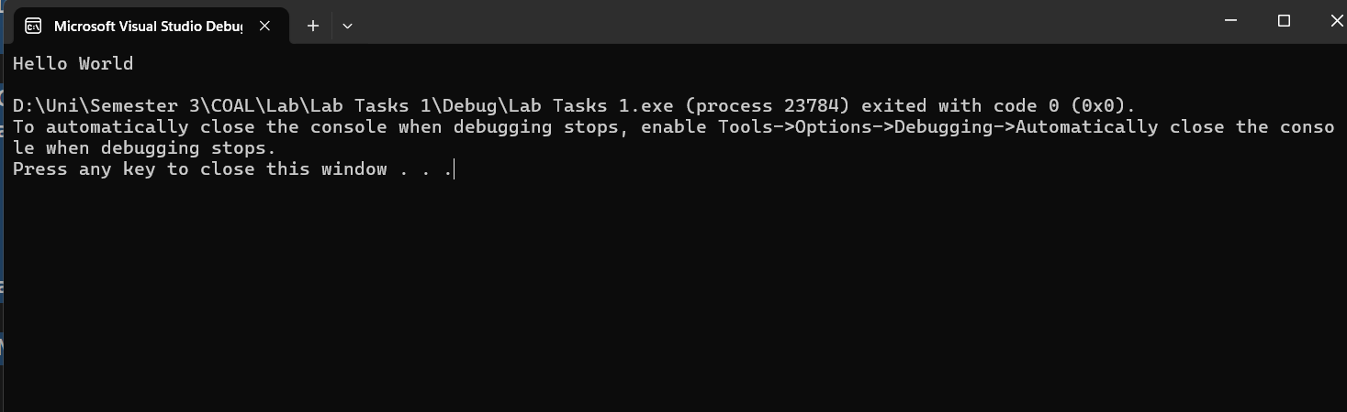

2.

INCLUDE Irvine32.inc

.DATA

v1 dword 1

v2 dword 2

v3 dword 3

.CODE

main PROC

mov eax, 1

mov ebx, 2

mov ecx, 3

call dumpregs

main ENDP

END main

